Recovery
Contents
- General Daily Recovery for Adaptation
- Rolling
- Icing
- Pain relievers (ibuprofen, acetaminophen)
- Sleep
- Nutrition
- Recovery from Sickness & Injury
- Sickness
- Injury

I. General Daily Recovery for Adaptation

i. Rolling
- What: Foam roller/Stick/Wheel/Softball/Golf ball/Wheels/Pipe/etc.
- Why: Increase blood circulation to increase recovery without increasing flexibility or decreasing muscle power. Self-massage muscles.
- When: Anytime but specifically before or after runs in place of stretching or when feeling tight.
- How Much: 1-5 minutes on the area. Longer if needed. Avoid rolling injured areas too much. Plenty of videos on how, here is one: https://www.youtube.com/watch?v=I9hl1DK5yTU

ii. Icing
- How: Apply ice pack or frozen item to area.
- When: When there is excessive soreness or inflammation. Avoid icing in base phase with general soreness. When competition comes, ice more frequently.
- How long: 10-15 minutes.
- Why: Decrease blood flow to area, usually to decrease swelling/inflammation.

iii. Pain relievers
- Why: Relieve excessive pain or inflammation
- When: Only if moderate to serious pain or inflammation or soreness. Avoid in base phase if possible. The general 200mg soreness from running is good, your body adapts to it.
- How much: About two tablets every 4 hours. Stop when pain is gone, avoid using them after pain is gone.
- What: Ibuprofen is best for anti-inflammatory/swelling. Other pain relievers for mild pain or fever.

iv. Days Off
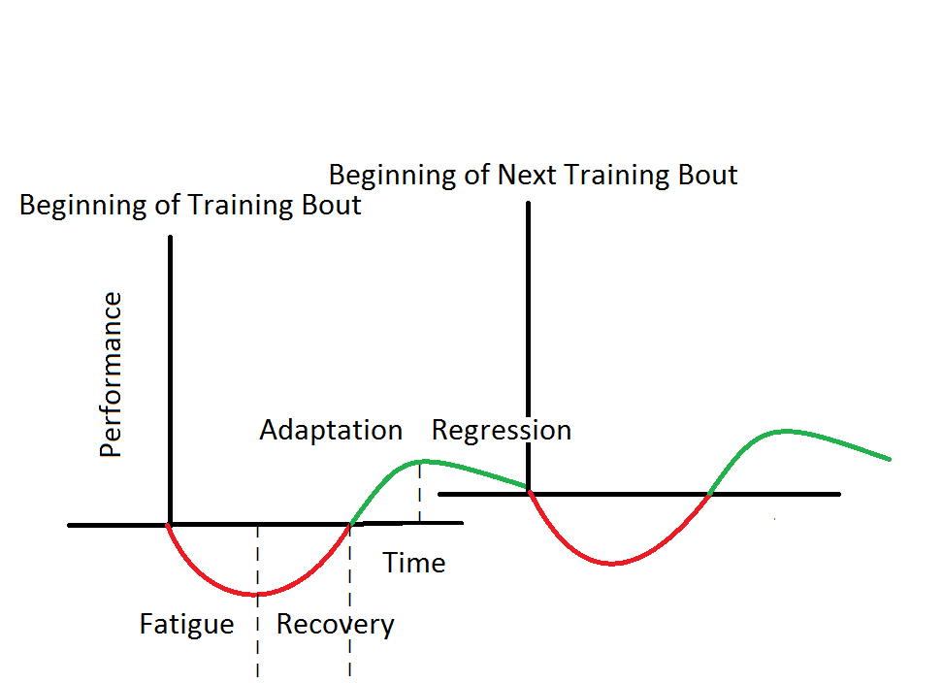
- What: No running or hard physical exercise.
- Why: Allowing extra time in the recovery phase after a hard week or few days. See graph*
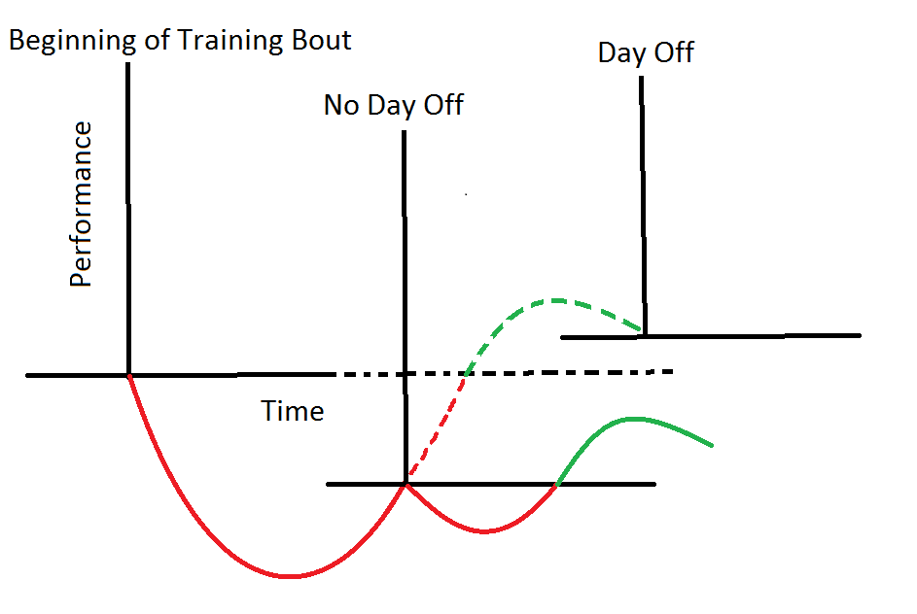

- When: When it’s on the training plan. About once every 14-21 days.

v. Sleep
- What: Regular, consistent sleep schedule. Need to achieve adequate deep sleep.
- Why: It is the time your body recovers and adapt from workouts.
- How Much: 8-9 hours/night. Naps between 15 min-2 hours
- When: Sleep at night. Nap no later than 3 p.m.
- Try not to use your computer/watch tv/phone within an hour of going to bed. They emit blue light that stimulates the brain.

vi. Nutrition
- See Nutrition Guide recovery section

II. Recovery from Sickness & Injury

i. Sickness
- Get diagnoses if unsure
- Take time off ex. 2-7 days if cold/flu like sickness.
  - Training while sick delays recovery from sickness which delays your training
  - Don’t try to tough through it
  - Goal is to recover from the sickness as fast as possible not to start running as soon as possible. Take an extra day when you feel ready to come back
- Extra sleep and general resting more often.
- Maintain excellent hydration.
- Don’t use medicine as a crutch to run.
- Once healthy, keep volume low for one week, but maintain previous intensity if possible.

ii. Injury
- Understand differences from general fatigue, minor daily pain, post-workout soreness and acute or chronic injury
  - Running stresses the body so you are bound to have aches and pains while training. Be cautious, but don’t limit your training when minor tweeks come up
- See a physical therapist/doctor/trained professional
- They will tell you to take time off, which is the best thing, but many injuries can be rehabbed while maintain fitness.
- Let your coaches know about any issues, they can help guide you to the right resources.

