Prevention
Contents
- Tendon flexibility
- Drills/Form
- Strength
- Shoes
- Recovery
- Gelatin

I. Tendon flexibility
- To help prevent injury, we want our tendons to be more flexible, not our muscles.
- Increase tendon flexibility by breaking collagen (main protein in tendons) cross links. Breaking the cross links will make your tendon more flexible and, simplified, take more force.
  - Perform isometric contractions for the area. Here is a quick video of quad/hamstring contractions: https://www.youtube.com/watch?v=9WoINw8UVbg
Hold the contractions for 30 seconds. The goal is to tire out the muscle and force the tendon to get involved. Do 1 or 2 holds per exercise.
  - Video doesn’t show calves. Get on a calf press machine at a gym, press against a weight you can barely do with two legs, remove one leg and hold the press. Do for both legs.
  - Working on tendon flexibility is good for prevention and rehab. Rehab example: achilles tendonitis
  - Moving weights slowly at a gym can increase tendon flexibility too. See strength section.

II. Drills/Form
- Having proper form while running can help prevent injury and aches. Our bodies are designed to run, so when we have correct form, we use the muscles that are meant for running, and we use them properly.
- Everyone has slightly different form, but there is a general form that everyone should converge on. Watch professional runners to see what good form looks like.
- To improve form:
  - Do a simple set of drills before and after your runs. Check out this article (towards the bottom under the Running Drills Video Demonstration); http://strengthrunning.com/2015/09/running-drills-to-improve-speed-form-efficiency/
  - Film yourself! Have a friend film you run at different speeds (for just ~20m) to compare yourself to runners with good form. Use slow-mo features if possible. Watch this video for angles to film yourself and compare to: http://www.nyrr.org/youth-and-schools/running-start/coaching-videos/high-school/form/form-101-running-posture
  - After filming, be conscientious about how your body feels when you make adjustments. Understand what it feels like to, for example, keep your head up, have your feet land under you, lean forward/backwards. When you know how this feels, you can make the adjustments on the run and know you are correcting your form since it will feel funny at first. “Proprioception (/ˌproʊprioʊˈsɛpʃən, -priə-/PRO-pree-o-SEP-shən), from Latin proprius, meaning "one's own", "individual", and capio, capere, to take or grasp, is the sense of the relative position of one's own parts of the body and strength of effort being employed in movement.” https://en.wikipedia.org/wiki/Proprioception.

III. Strength
- The stronger your muscles are, the less likely you are to become injured from general overuse injuries. Meta-study: http://bjsm.bmj.com/content/48/11/871.long
- Many people have different backgrounds regarding strength training, but there are basic exercises and rules to follow.
- Two strength sessions a week. Do strength sessions a minimum of ~5-6 hours before or after a run to allow adequate recovery for your muscles. Do what works best for you, though.
- Rules
  - Slow movements to increase tendon flexibility. Fast movements will tighten. Tighter tendons are good for performance and end of season competition.
  - 2 sets for each exercise
  - Choose a weight that by the end of each set you should just barely get to failure (can’t do another repetition). Maxing out to failure will promote more muscle growth (which isn’t bad, but runners want to be as light as possible). Going to just barely failure will make you stronger without gaining too much muscle.
  - Move up a small amount of weight as you get stronger. Only move up when what you have been doing gets easier.
- Legs (look up exercises as needed)
  - Leg extension (13-15 reps per set)
  - Leg curls (13-15)
  - Leg press (25)
  - Calf press/raises (25-30)
  - Toe taps (30-40)
- Upper body (look up as needed). Mostly working on some back and chest. Not much need for a lot of other muscle groups (biceps, shoulders, traps, etc.)
  - Lateral row (13-15)
  - Chest press (13-15)
  - Chin ups (use assisted chin up/dip machine) (10)
  - Dips (use assisted chin up/dip machine) (10)
  - Core (planks and related exercises) (6-8 minutes of core work)

IV. Shoes
- A good shoe goes a long way
- Find out if you are neutral (land on the center of your feet) or stability (usually over pronation, land on the insides of your feet. Under-pronation is landing on the outside of your foot, less common)
- If you have a frequent shin/calf pain/tightness, try a shoe with a higher drop (the difference in height between the back and the front of the shoe). This will put you more on your heels and take stress off your lower legs.
- If you have frequent knee problems, try a shoe with a lower drop. This will put you more on your toes and take stress off your knees but more on your lower legs.
- Working on good form will allow you to run in more shoes because proper form will put stress on your legs in the “right” places where your body has been adapted to run.
- Choose a more cushioned shoe if you have knee or lower leg aches.
- Replace shoes about every 300-500 miles depending on the shoe. Log your miles to know when to replace shoes.
- Replace your shoes before you think “I should probably replace my shoes”. Running in worn out shoes can lead to problems.

V. Recovery
- See “Recovery” resource.
- Part of injury prevention is making sure you recover after runs.
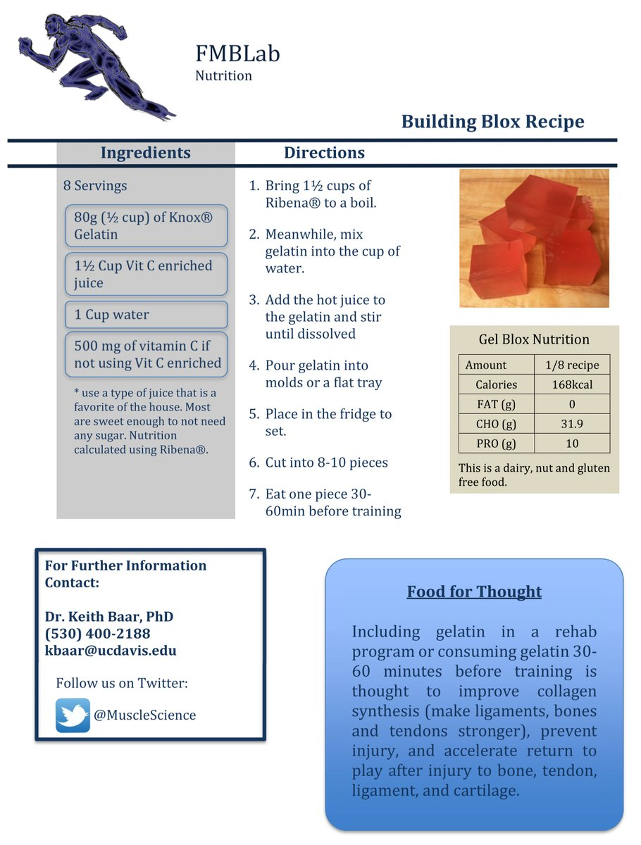
VI. Gelatin
- Long story short, consuming
gelatin can increase your
collagen levels which will
improve your tendon health.
Great for shin issues, tendinitis,
And joints.
- As the information to the right
indicates, consume before
running. You can do this as
frequently as you want.
You need to be consistent
(3-4 times a week) to keep
Your collagen levels higher.
- Gelatin is an animal product, so a
possible alternative might be
pectin (plant derived). Needs
research, though.

